


Client-Side Development
Coursework Two
Module Code (CRN): COM109 (65807)
Module Coordinator: Md. Haroon Sihan

Student Name: Junaeid Hasan
Student Id: 20033816
GitHub Repository Link: https://github.com/SabihaChowdhury789/Group-H

Introduction
This project’s About page was my responsibility in terms of content development and style implementation. I arranged the page’s components using HTML and applied CSS to ensure the layout design, formatting, color scheme, and responsiveness were visually appealing across all devices.
In addition, I added dynamic features with JavaScript. I created a modal system to display product descriptions and the number of products automatically updates when a product is added to the cart. Moreover, the data is saved using the browser's local Storage, so that the information is not lost even after a refresh. These features have made the website visually beautiful, functional, and user-friendly.

Screenshot of the About Page
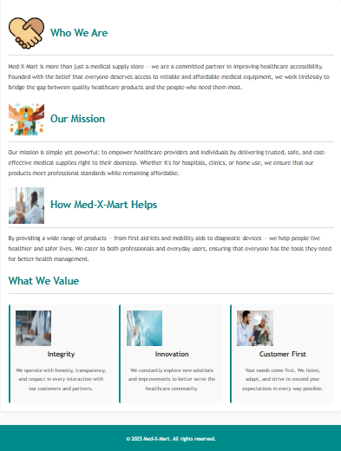

Screenshot of About page HTML Code
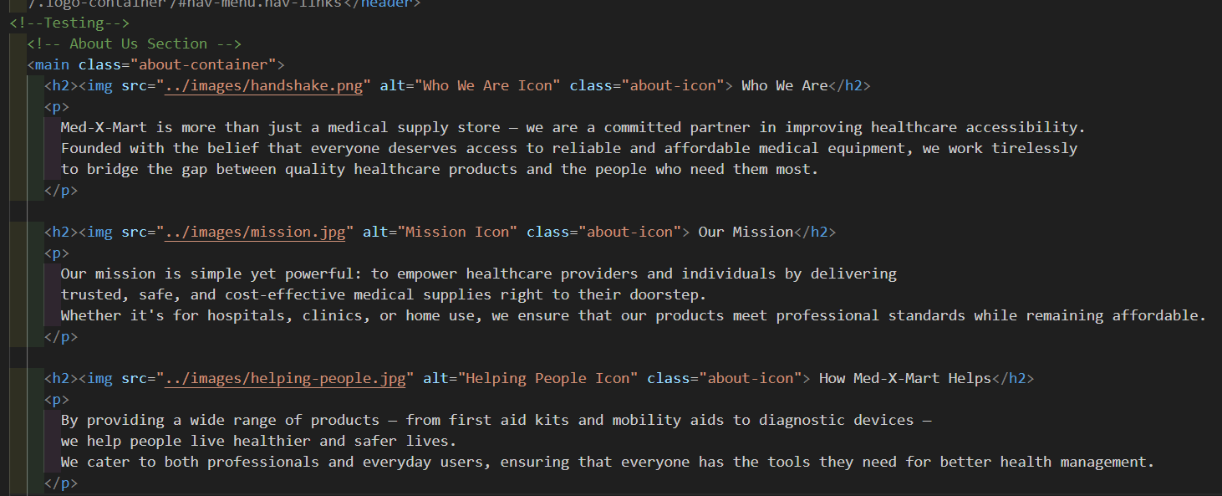

Explanation of how the HTML code works
- DOCTYPE, Head & CSS Link
The `<html lang="en">` tag specifies the language for spell-checkers, SEO, and screen readers. This About Us page is in standards mode with HTML5 `<!DOCTYPE html>'. '<head>` includes: 'meta name="viewport" content="width=device-width, initial-scale=1.0"" responsive scaling, 'meta charset="UTF-8"` (Unicode),`<title>About Us-Med-X-Mart</title>' proper tab title, and `<link rel="stylesheet" href="../css/about.css">`.
- Header and Navigation
In the header section, I first cleaned up the branding. Here, I've shown the logo with <img class="logo" alt="Med-X-Mart Logo">, to maintain accessibility. This is the primary title of the brand. I've used <div id="hamburger" class="hamburger">&#9776;</div> for mobile navigation. Later, when the user clicks on <nav id="nav-menu">, I'll utilize JavaScript to reveal and hide it. I've included links to Home, Products, About Us, Contact, and Cart under <nav class="nav-links" id="nav-menu">. JavaScript will automatically update the cart with <span id="cart-count">0</span>.

Screenshot of About page HTML Code
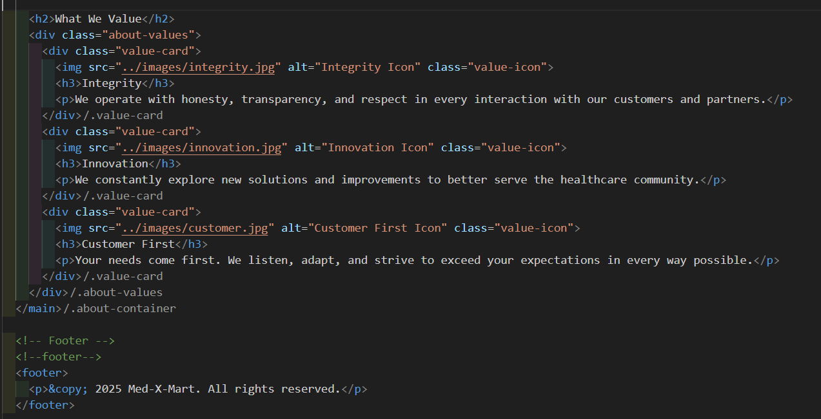
- Main About Section
I used <main class="about-container"> for the main content it tells screen readers and browsers, “This is the main content of the page.” Then I put section-based headings so that the user can scan quickly. I added a small icon (<img class="about-icon">) before “Who We Are” it visually conveys the point right away. In this paragraph, I clearly wrote we are not just a store, but a partner in making healthcare accessible; this kind of statement clarifies the tone of voice and brand values of the page. In “Our Mission,” I highlighted the three pillars target, delivery model (delivered to the doorstep), and “trusted/safe/cost-effective” so that the reader understands the standards we work by. In “How Med-X-Mart Helps”, I have mentioned both the product range (first aid, mobility aids, diagnostics) and who benefits (professionals and general users); this makes the “use-cases” clear.
The most visual part is “What We Value”. Here I have created three <div class="about-values"> containers each with an icon (.value-icon), title (<h3>) and explanation (<p>). In the Integrity card, I have anchored the three core behaviors “honesty, transparency, respect”; in the Innovation card, “new solutions & improvements” signals of continuous improvement; in the Customer First card, “listen, adapt, exceed expectations” a commitment to customer-demand-centric work. I will make the card layout responsive with CSS grid/flex one column on small screens, 2–3 columns on large screens this increases scannability.

Product Details Modal HTML Code
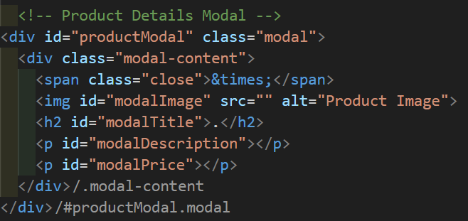
- Product Modal
I used <div class="modalcontent"> to keep the main content of the product details modal after creating the full modal container using <div id="productModal" class="modal">. I used <span class="close">&times;</span> to close the modal, where the &times; symbol denotes a close mark (×).
The product image may be dynamically set using JavaScript; therefore, I used the <img id="modalImage"> tag to display it.
I displayed the product title, description, and price underneath the image using <h2 id="modalTitle">, <p id="modalDescription">, and <p id="modalPrice">, respectively. Because each element has a unique id, JavaScript can easily update the content.

- Footer
In the footer, I have a very simple <footer>, with just <p>&copy; 2025 Med-X-Mart. All rights reserved. </p> this line gives the page a formal finish, and the copyright year is update-friendly. If desired, accessibility can be further enhanced here by using aria-label or landmark roles.
I have paid special attention to usability (UX) and accessibility (a11y). I have given alt to all important images, followed the heading level (H1, H2, H3), and placed the navigation with links inside <nav> these are semantic signals for search engines and screen readers. I have chosen the hamburger menu toggle pattern for mobile navigation; later toggling aria-expanded in JavaScript will also be good for accessibility. In the future, cart counting, menu toggles, and even smooth-scrolling in sections all of these interactions will be easy to implement, because I’ve organized the IDs/classes into functional names (e.g. #nav-menu, #cart-count, #hamburger).
Overall, this About page conveys both brand story and credibility and the design structure are designed so that users can quickly understand who we are, what we do, why we do it and what values are most important to us.

Screenshot of About page CSS Code
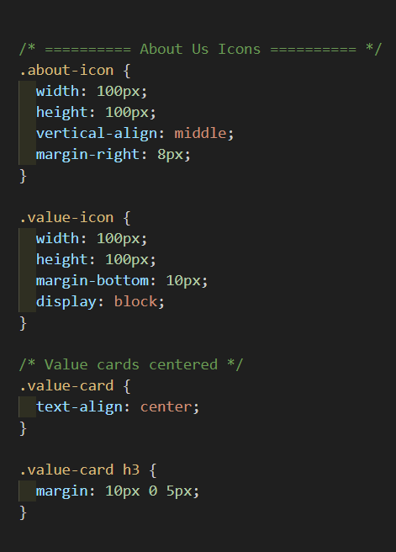
Explanation of how the CSS code works
- Main Container (About Section): First, I styled the entire section nicely in the .about-container section. In this case, I set the maximum width of the content to 900 pixels so that it does not look widescreen or stretched out, it looks good. I set margin to 40 pixels on the top and bottom and auto on left and right to center the content which allows some space vertically. For the content, I set padding to 20 pixels so there is space between the content and container boundary. Using background: white, border-radius: 8px, and box-shadow, I was able to give the content a card like smooth and professional look while making it softly shaded.

- Heading (Title Styling): In the selector. In about-container h2, I set a teal color due to it being one of ours brand colors. For the bottom border of the title, I used 28px font-size, 2px solid #ddd. I though this time to create a visual spacing then used padding-bottom which I created enough room of space between the title and the line. This ensures that the title pops.

- Paragraph (Text Styling): The line spacing in.about-container p is simpler to read because of its line-height of 1.8. hue: The light dark gray hue #444 is aesthetically pleasing. The most common font size for web text is 16 pixels.

- Value Section (Flexbox Layout): .about-values has flexbox. Using display: flex; flex-wrap: wrap; allows the cards to be arranged side by side, and on small screens, they are arranged line by line. I have left a gap between each card with gap: 20px and separated it from the content above with margin-top: 30px.

- Value Card (Card Design): .value-card has arranged each value as a separate card. Flex: 1 1 250px means that each card will take up at least 250px of space but can grow evenly if there is space. I have given a light gray background with background: #f9f9f9. I've added a colored strip on the left side with border-left: 5px solid teal which makes the card stand out. I've added padding and border-radius to give the card a nice soft and spaced shape.

Inside, I've made the .value-card h3 heading a dark black (#222) and the text in .value-card p a light gray (#555), for contrast.

- Body (Global Styling): I've set the entire website font in the body selector. I've used 'Trebuchet MS' and some fallback fonts so that it looks good in any browser. I've kept the background light #f8f9fa and the text #333 this combination is very comfortable to read.

- Header (Navigation Bar): The header section features a teal background, white text, and Flexbox to arrange the navigation and logo on either side. I detached the header and added a light box-shadow underneath to give it a floating appearance, making sure the header always stays at the top when scrolling.

- Navigation (Menu Links): I arranged the navigation links side by side using Flexbox. Every link is displayed as a circular button with a 20px border radius, a white background, and the proper padding. The links appear more appealing when hovered over since the backdrop is rgba (255,255,255,0.15) and the text color is #ffeb3b.
- Logo and Icons (Images): I set the logo size to 150x150px in the .logo class and gave it object-fit: contain so that it wouldn't be distorted. .about-icon and .value-icon both 100x100px, and I used margin to align them nicely with the text or card. .value-card {text-align: center;} makes the icon, title, and text of each card nicely centered.

- Footer: The footer's white text was then centered on a dark cyan background. The gap was kept apart from the text by using padding of 15 pixels and the margin-top of 40 pixels.

My goal in designing this CSS code was to make the About Us area look accessible, professional, and easy to read. I have created a unified design using card layouts, responsive flexbox, and the brand color (teal).

Screenshot the JavaScript Code
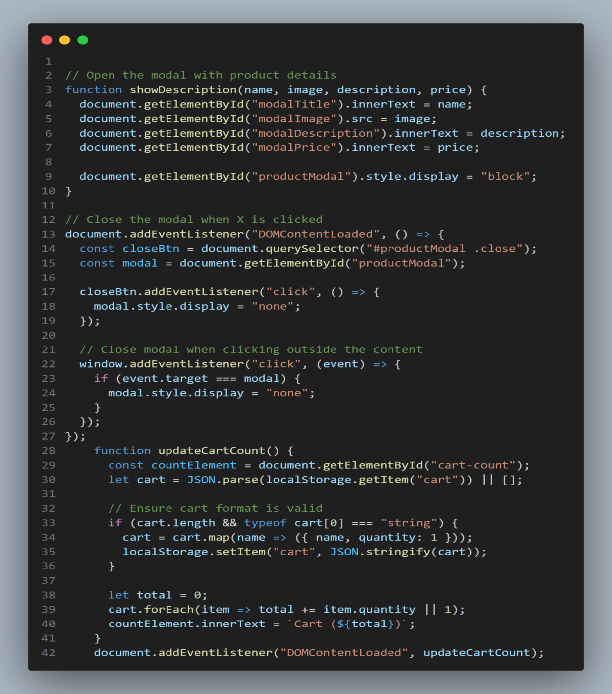
Explanation of how the JavaScript code works
Objective
The main purpose of this code was to create a product details modal system in a web application and simultaneously dynamically update the number of products in the cart. Below I explain each part.
- Product Modal Display
First I created a function called showDescription(name, image, description, price). Through this when a product is clicked the name, image, description and price of the product is dynamically displayed inside the modal. For that I selected a specific HTML element using document.getElementById() and updated the values using innerText and src. Finally I used style.display = "block" to make the modal visible.
- Closing the Modal
I added two types of interactions to close the modal.
When the X button is clicked: I identified the close button through querySelector("#productModal .close") and arranged to hide the modal on the click event.
When clicking outside the modal: I've used window to detect the click on the entire window.insertEventListener("click"). When the user clicks directly on the modal's background, it vanishes. These two features improved the user experience.
- Cart Count Update
Then I wrote a function called updateCartCount() which counts the total number of products in the cart and displays it dynamically next to the navigation bar. For that I fetch the data from localStorage (localStorage.getItem("cart")) and convert it to JSON. Then I verify the format of the cart. If there is only the product name then I convert it to object form where I add the default quantity: 1. Then I add the number of each item to get the total and display it on the screen in Cart (X) format.
- Event Trigger
I decided to go with DOMContentLoaded event since it makes the entire system operational. So, by doing this the updateCartCount function is triggered when page loads And User can see count in cart from time of load.
Conclusion
I came up with an interactive feature to demonstrate this code I built a version of this interactive in which when the user clicks on any product it shows full info (in the modal) so that if he closes modal, cart count also updates real time. And despite being slightly over the top in applying some overly aggressive techniques, it is all done on a professional level and still manages to be simple for use.

